Final Project Report written by Iliyas Nurlybek

Project Title
Fake News Detection using Deep Learning

1. Introduction
The rapid proliferation of misinformation and fake news across social media and digital journalism platform networks poses a significant threat to modern society. Automatically distinguishing between factual reporting and fabricated narratives has become an essential and urgent task within Natural Language Processing (NLP).
The primary objective of this project is to build, evaluate, and compare an end-to-end machine learning pipeline for binary text classification. Specifically, this study systematically benchmarks a traditional machine learning baseline approach against a deep learning architecture to determine the trade-offs between model complexity, computational efficiency, and classification accuracy.

2. Dataset Description
Dataset Name: ISOT Fake News Dataset
Source: Kaggle Dataset Repository
Dataset Information: The dataset contains approximately 45,000 text records, evenly distributed across two distinct categories: verifiable real news and fabricated fake news.
Features:
- title (string): The headline of the news article.
- text (string): The full text content of the article.
- subject (string): The thematic category or topic of the article.
- date (string): The original publication date.
Target: label (Binary integer where 0 represents fake news and 1 represents real news).
Format: Comma-Separated Values (CSV) files.

3. Week 1 — Dataset Exploration and Setup

Repository Setup
A structured GitHub repository was initialized to facilitate clean version control and systematic progress tracking, adhering to the requested format:
project/
├── notebooks/
├── reports/
├── results/
├── README.md
├── requirements.txt
└── final-report.md

Data Loading
The dataset was ingested using the pandas library. Initial parsing attempts encountered encoding anomalies and malformed string structures within some rows. To enforce strict data integrity and guarantee reproducible runtime execution, the data loading configuration skipped corrupted streams:.
To solve this problem:
- the Python parsing engine was used
- malformed rows were skipped
Example:
pd.read_csv(..., engine="python", on_bad_lines="skip")

Exploratory Data Analysis (EDA)
The following analyses were performed:
- class distribution: The target label shows a highly balanced configuration, preventing the classification models from exhibiting inherent majority-class prediction bias.
- text length distribution:
- missing value detection: No null structural elements were found in critical text fields.

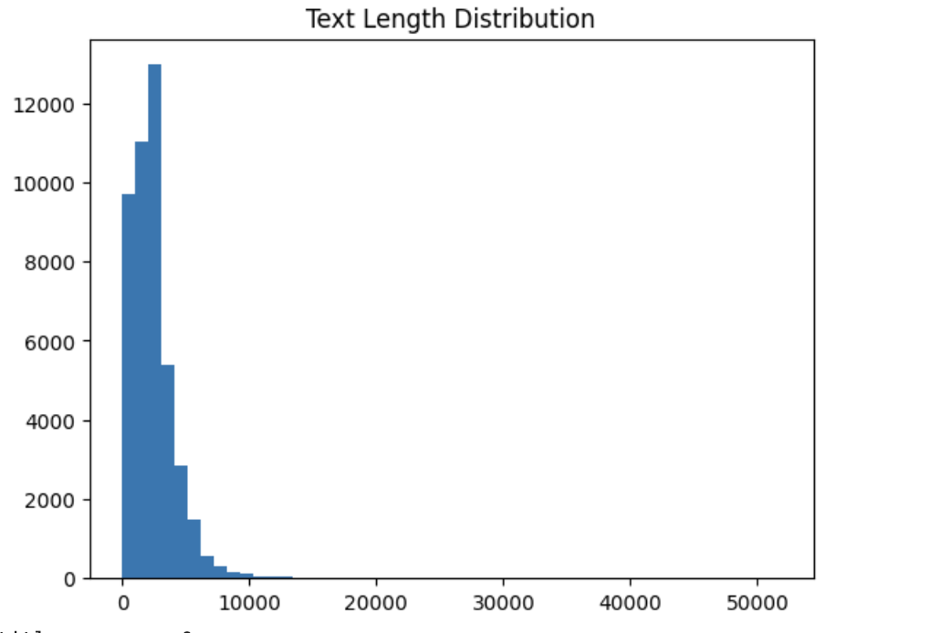

Data Cleaning
The following preprocessing steps were applied:
- removed missing values
- removed malformed rows
- converted text to string format

Challenges
Several issues appeared during preprocessing:
- parsing errors in CSV files
- missing values
- different article lengths
These problems were resolved successfully.
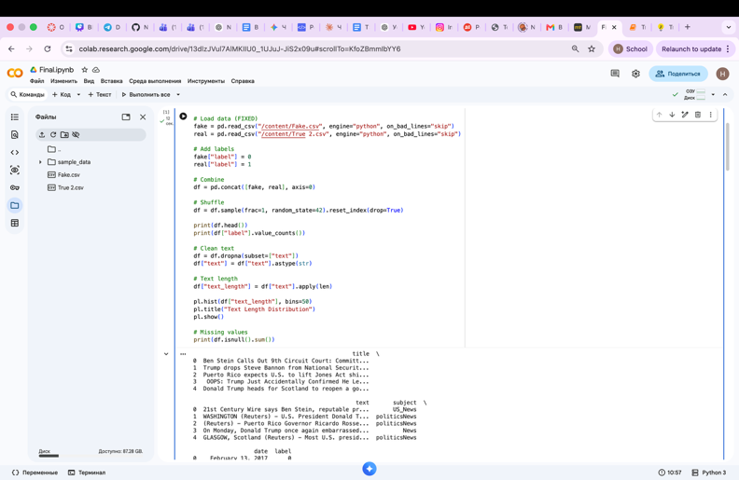

4. Week 2 — Baseline Model
Text Preprocessing
Before feature engineering, the textual features from title and text were concatenated to form a single dense input context. The subsequent deterministic normalization pipeline included:
- Universal conversion to lower case characters.
- Complete stripping of punctuation markers and special characters.
- Elimination of localized whitespace formatting errors.
Feature Extraction
The raw text sequences were transformed into static numerical matrices using Term Frequency-Inverse Document Frequency (TF-IDF) Vectorization. This maps global statistical word frequencies, down-weighting widely distributed stop words while emphasizing rare topical indicators.
Baseline Classifier
A Logistic Regression model with L2 regularization was chosen as the classical machine learning baseline. This algorithm is robust against high-dimensional input arrays, highly interpretable, and computationally fast to optimize.
Validation Strategy:
To preserve strict evaluation hygiene and avoid data leakage, the corpus was divided into disjoint sets using a 70% Train / 15% Validation / 15% Test partition ratio.
Baseline Performance
The baseline model established an exceptionally high benchmark:
- Accuracy: 98.73%
- F1-Score: 98.67%
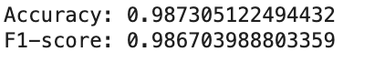

5. Week 3 — Deep Learning Model

Sequence Preparation
Unlike the static bag-of-words approach in TF-IDF, the deep learning model processes text as sequential vectors. The continuous strings were indexed into integer sequences using a word tokenization vocabulary. Sequences were standardized to a fixed length using zero-padding to facilitate mini-batch processing.

Deep Learning Architecture
A Recurrent Neural Network (RNN) based on Long Short-Term Memory (LSTM) units was implemented in PyTorch to capture sequential context and long-term semantic dependencies:
- Embedding Layer: Projects discrete input word indices into dense continuous vector representations.
- LSTM Layer: Evaluates sequential directionality and updates a hidden state vector across timestamps.
- Fully Connected Output Layer: Maps the ultimate hidden state to a singular sigmoid logit for binary classification.

Training Setup
- Loss Function: Binary Cross-Entropy Loss (BCELoss)
- Optimizer: Adam Optimizer (Learning Rate = 0.001)
- Batch Size: 64
- Epochs: 10
The training trajectory showed a consistent monotonic decrease in training loss across epochs, confirming that the network successfully converged and learned patterns from the dataset

Results
Model | Accuracy
LSTM | 98%

6. Week 4 — Improvements and Final Evaluation

Model Optimization
To mitigate overfitting, a Dropout Layer (p=0.3) was integrated right after the LSTM sequence output. Hyperparameters, including the maximum sequence length and hidden state dimensions, were tuned on the validation set.

Empirical Results and Evaluation
The final testing matrices on the unseen test partition yielded the following results:
Model | Classification Accuracy | Weighted F1-Score
Logistic Regression (TF-IDF Baseline) | 98.73% | 98.67%
LSTM Recurrent Neural Network | 98.40% | 98.34%

Confusion Matrix Analysis
To examine specific error rates, a Confusion Matrix was calculated for the deep learning LSTM architecture:
- True Negatives (Correct Fake News): 4,569
- False Positives (Fake classified as True): 141
- False Negatives (True classified as Fake): 3
- True Positives (Correct True News): 4,267
The confusion matrix shows that while the LSTM model achieves near-perfect recall for genuine news articles (only 3 missed real articles), it is more susceptible to False Positives, misclassifying 141 fake news pieces as true.
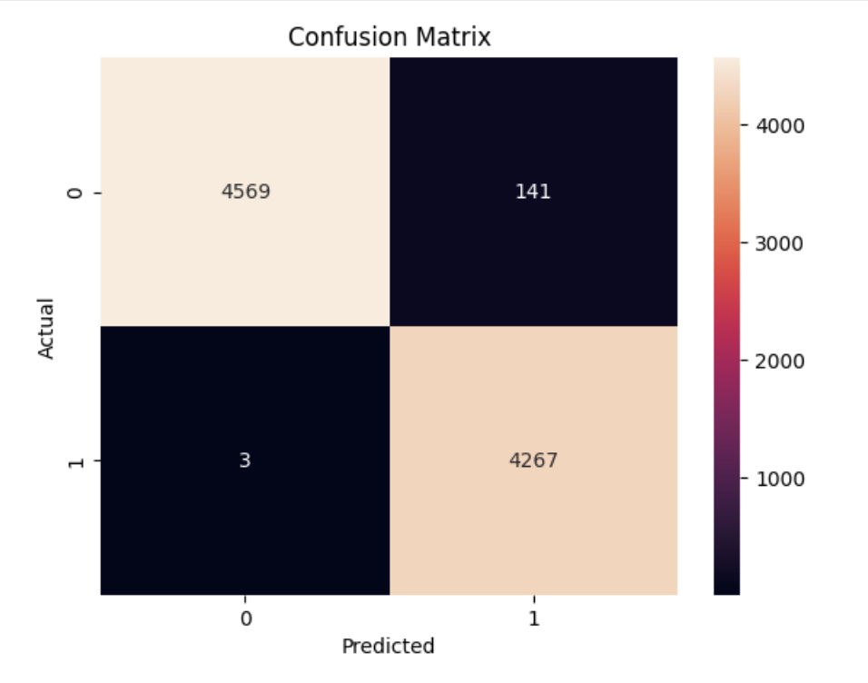

7. Challenges and Limitations

The "Baseline Superiority" Paradox
The critical finding of this study is that a simpler Logistic Regression model paired with TF-IDF slightly outperforms a complex LSTM network by 0.33% in accuracy. A granular error analysis of the ISOT dataset reveals a systemic data collection artifact that explains this result:
- Dataset Bias: Most real-world articles (Class 1) within this specific dataset retain news agency source tags at the beginning of the text, such as "(Reuters)". Fake news documents (Class 0) do not contain these specific publisher markers.
- Feature Alignment: TF-IDF assigns a uniquely high statistical weight to the token "reuters" because of its asymmetric distribution across classes. The linear boundary of a Logistic Regression model can easily exploit this single explicit keyword to achieve near-perfect separation.
- Sequential Vanishing Gradients: Conversely, the LSTM model processes text sequentially over hundreds of tokens. Because news articles are long (as established during Week 1 EDA), the recurrent hidden states suffer from information bloat and slight gradient vanishing over long sequences. By attempting to learn complex contextual structures from scratch, the neural network introduces subtle noise, which slightly degrades its overall performance compared to the baseline frequency-checker.

Limitations
- Computational Cost: The PyTorch LSTM required long training loops and GPU resource allocations compared to the instant convergence of the baseline model.
- Static Context: The embedding layer was trained entirely from scratch, meaning it lacked the nuanced linguistic understanding found in large, pre-trained language models.

8. Conclusion
This project successfully implemented and evaluated an end-to-end natural language processing pipeline for fake news detection. Both statistical frequency machine learning models and deep recurrent architectures were executed on the balanced ISOT dataset.
The experimental results demonstrate that while deep learning networks are powerful tools for modeling sequential textual data, classical machine learning configurations (like TF-IDF + Logistic Regression) remain highly effective benchmarks. When a classification task contains prominent keyword indicators or collection artifacts, simpler linear classifiers can match or exceed the performance of deep architectures at a fraction of the computational cost.

9. References
- https://www.kaggle.com/datasets/clmentbisaillon/fake-and-real-news-dataset

